# Doctor Module

1. Add the Mandatory symbol on the profile image url and change the file upload design  
   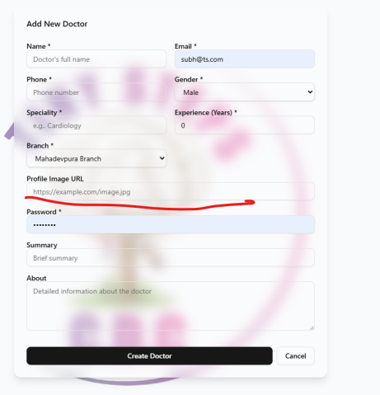
2. If I am passing same email ID and mobile number which is already registered there showing 500 error.  
   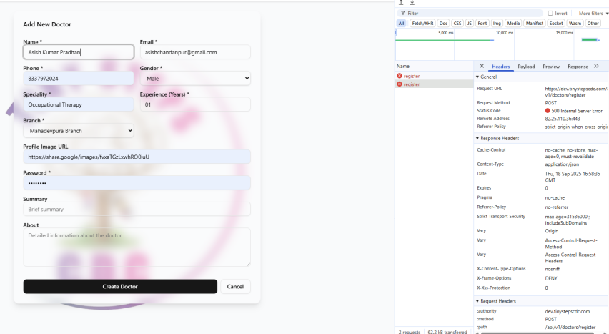
3. In the edit page data’s is not displaying   
   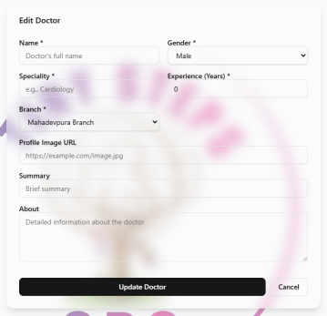
4. Search filter is not working with Speciality conditions
5. Manage Branches Branch option is not required  
   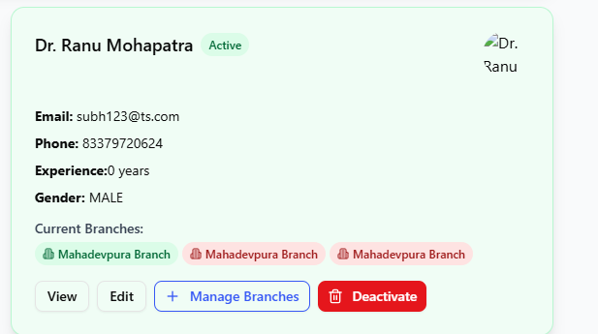
6. On the view page no need rating and total Reviews options  
   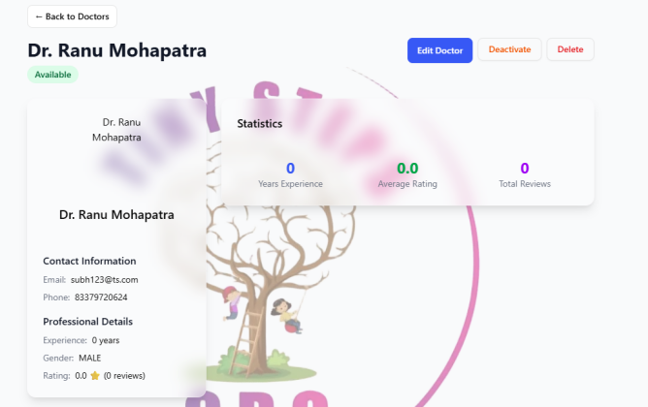
7. Profile photo is not displaying on the lists and view page
8. Remove Summary or About or make it Remarks fields on the create and edit page  
   along with view page . Field is missing  
   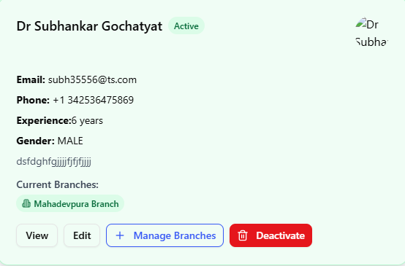
9. If I am making as inactive then in the dashboard total count is showing correctly but after clicking it inside the tab showing wrong count and doctor details is showing there.  
   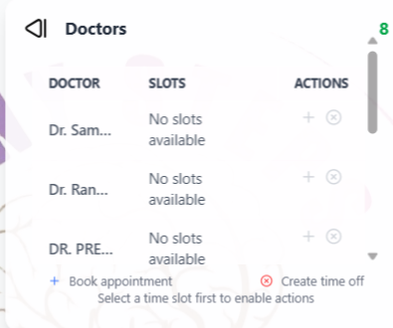
10. If admin is doing activate in the all-branch section, then in the mahadevpura branch its not changing the status to activate . showing still deactivate
11. No need delete option in the doctor
12. If doctor status deactivate no need to display in the timing module
13. When page loads clear cookies and local storage  
      
    Award:
14. Background need to be change as white for edit and create page
15. Delete is not happening
16. In edit page doctor a to doctor b name is not saving.
17. Deactive doctor name no need to display in the select a doctor page
18. If summary is going above 250 words throwing 400 error. Add error messsage  
      
    **Qualifications Management**
19. Background need to be change as white for edit and create page
20. Delete is not happening
21. In edit page doctor a to doctor b name is not saving.
22. Deactivate doctor name no need to display in the select a doctor page
23. If summary is going above 250 words throwing 400 error. Add error message  
    **Specializations Management**
24. Background need to be change as white for edit and create page
25. Delete is not happening
26. In edit page doctor a to doctor b name is not saving.
27. Deactivate doctor name no need to display in the select a doctor page
28. If summary is going above 250 words throwing 400 error. Add error message  
      
    Patients
29. Except patient page all the pages is loading in the patient module.
30. No need email as mandatory.

Timing Management

1. **Time Offs functionality is missing**
2. **Practice id is showing as mandatory**
3. **On the edit employee description added data is not displaying in the lists page.**
4. **Delete is not happening.**
5. **Edit page and create page is black behind**
6. Deactivate doctor name no need to display in the select a doctor page

# **Session Types Management**

1. Check if this session type is currently available >> use cases

**Session Management**

1. Deactivate doctor name no need to display in the select a doctor page
2. Along with if the doctor is not assigned any timing in the calendar
3. Change dollar symbol to Indian rupee
4. We cannot assign one doctor to multiple session  
     
   Schedule
5. Day mismatch in the calendar showing as day off here but in the monthly showing as Monday off but in the weekly its showing as correct  
   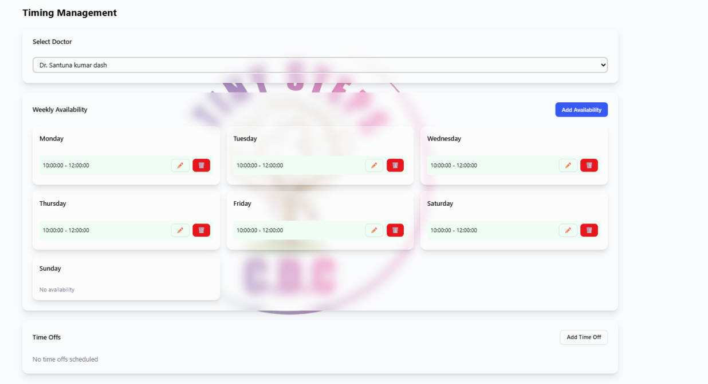  
   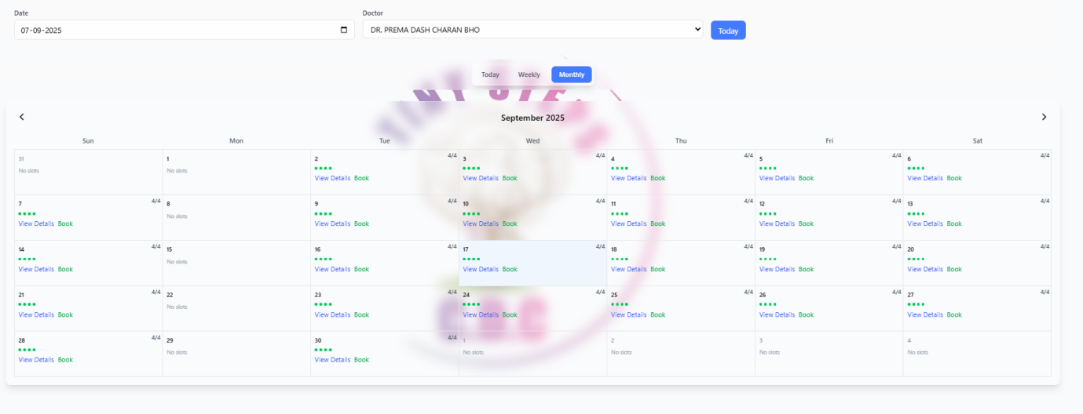
6. Getting error for tomorrow booking   
   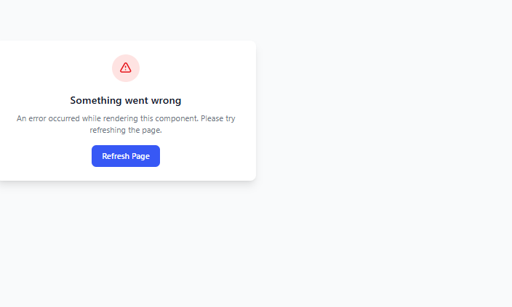  
   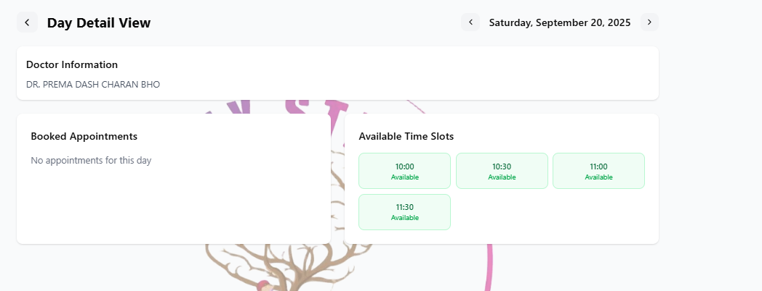
7. If the doctor is assigned one session such as music therapy in the session but while create new appointment time admin can see all type of session for the doctors so here mapping should be required  
   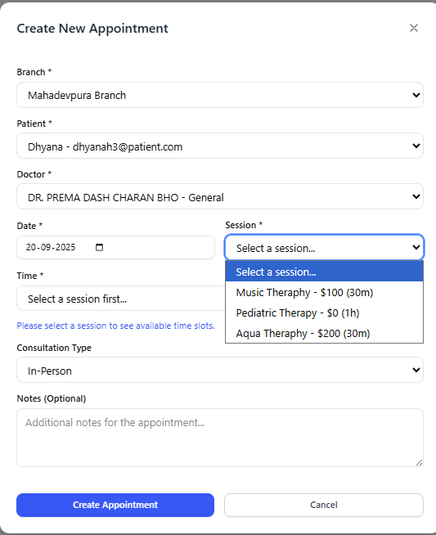
8. Not required any modify duration option
9. Here missing 3 green dot symbol  
   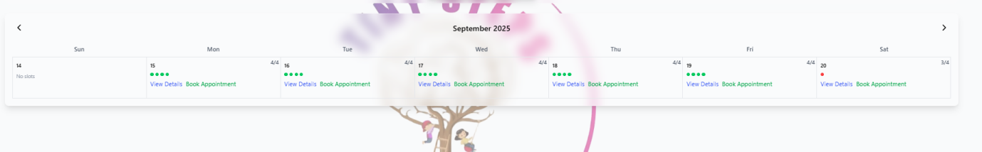
10. While booking on the dashboard the data is not displaying  
    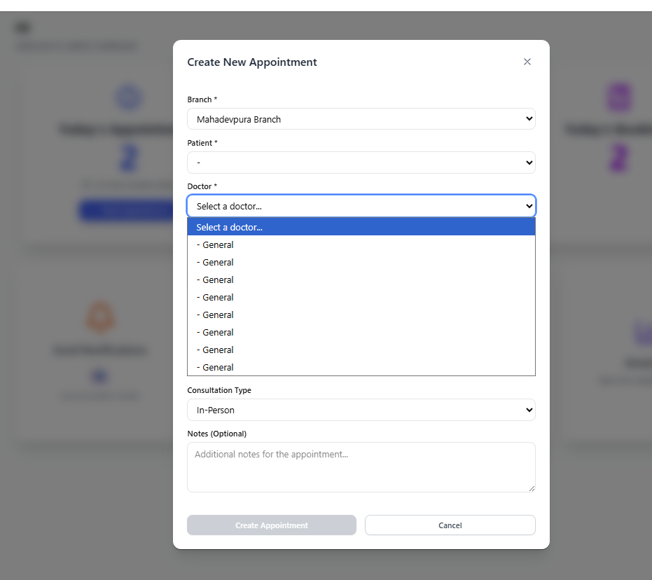
11.   
    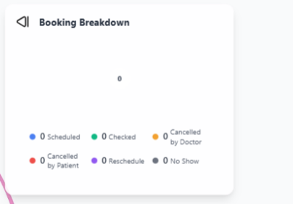
12. Unable to book appointment here  
    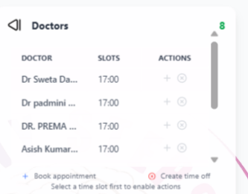
13. Getting error message “Failed to execute json on response Unexpected end of json input”

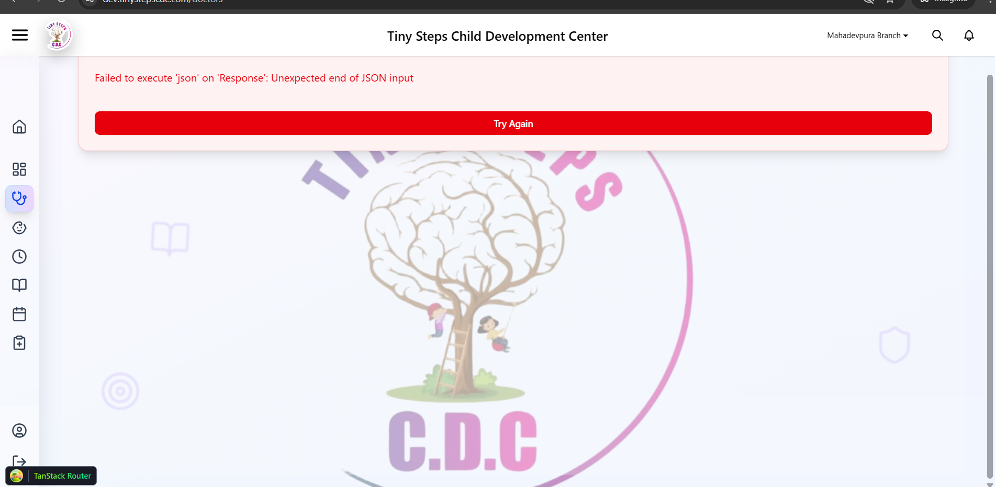

1. Sometimes we are facing Error loading Docotors

Failed to fetch doctors with branch status

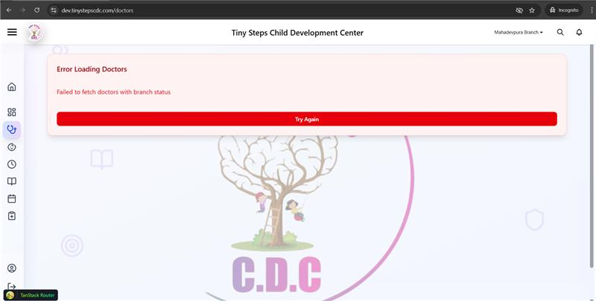

1. Unable to create branch while managing the branch feature

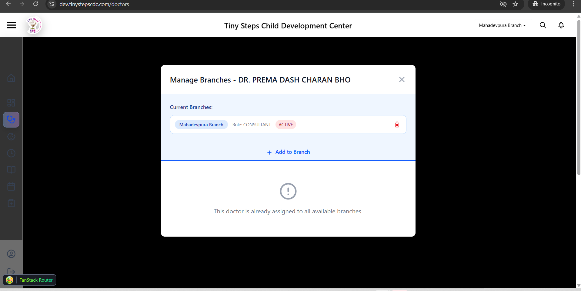

1. While doctor creation/updating no validation toast message is displaying
2. While updating the doctor details the existing doctor specialist field value is not displaying

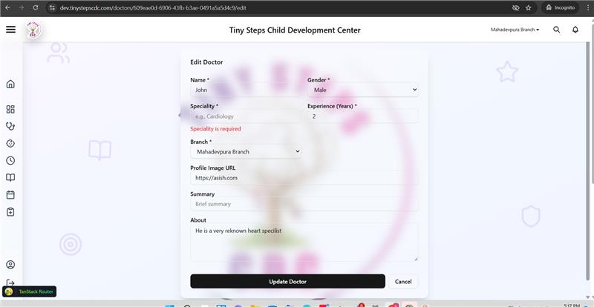

1. while searching doctor based on the experience that text filed accept e letter it should not accept, it should accept only numeric valued

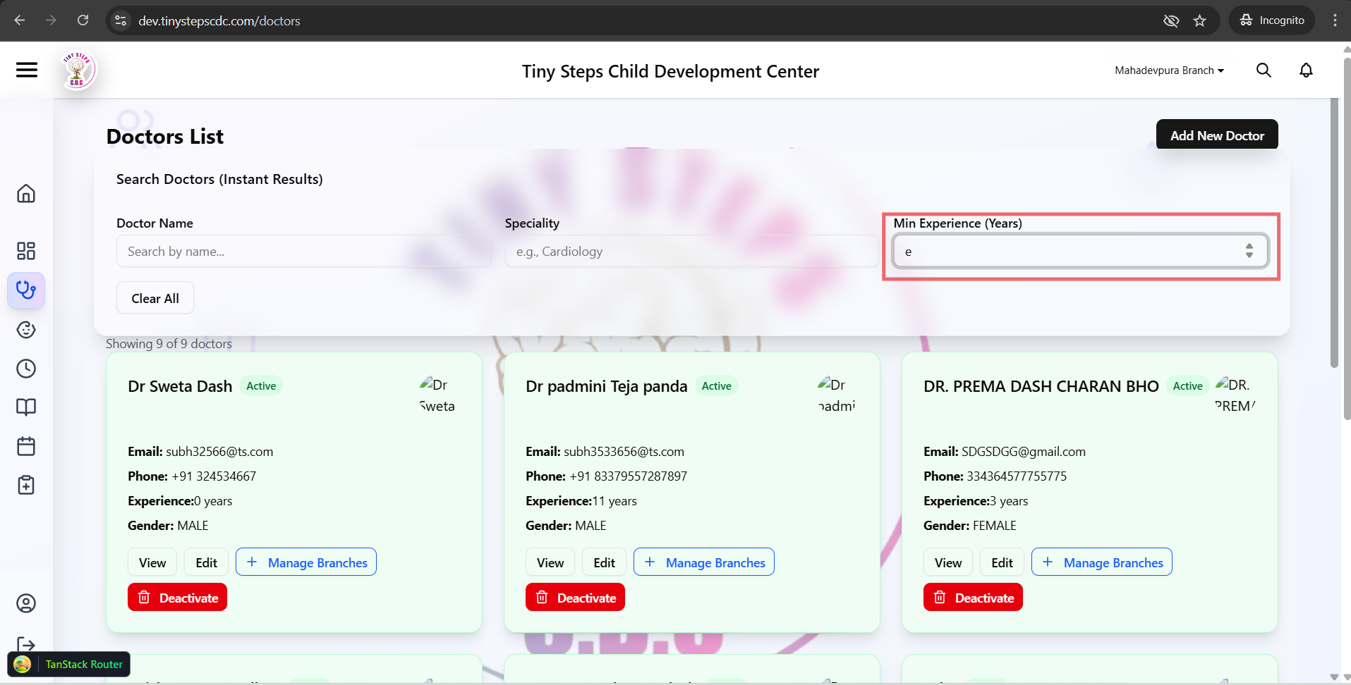

1. No field value limit is restricted

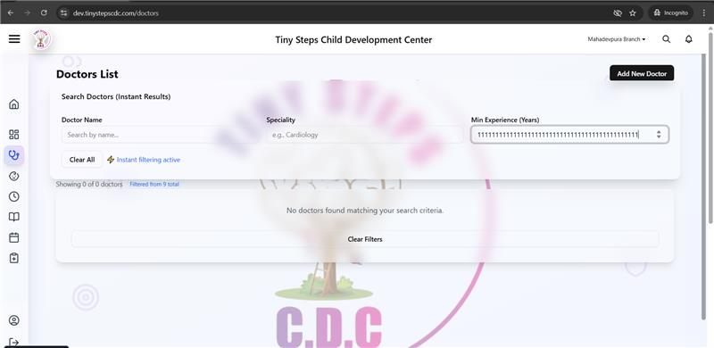

1. After searching with invalid input the list page is showing total count is 9 , it should display as zero

